Assignment 3

Write a Python program to implement your own myreduce() function which works exactly like Pythons built in function reduce()

**Code**

#Assignment 3

def myreduce(lst1):

prod=lst1[0]

for i in range(1,len(lst1)):

prod*=lst1[i]

return prod

x= myreduce([5,4,3,2,1])

print("Output of this list using myreduce is",x)

**Screenshot:**

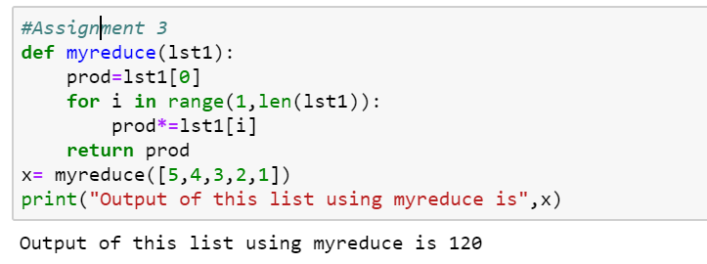

Write a Python program to implement your own myfilter() function which works exactly like python’s built in function filter

**Code**

#Assignment 3

def myfilter(lst1):

lst2=[x for x in lst1 if x>2]

return lst2

print(myfilter([5,4,3,2,1]))

**Screenshot:**

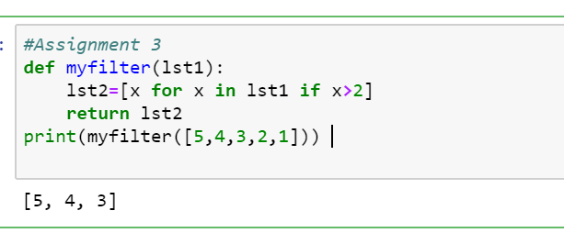

3. Implement List comprehensions to produce the following lists.

Write List comprehensions to produce the following Lists

['A', 'C', 'A', 'D', 'G', 'I', ’L’, ‘ D’]

['x', 'xx', 'xxx', 'xxxx', 'y', 'yy', 'yyy', 'yyyy', 'z', 'zz', 'zzz', 'zzzz']

['x', 'y', 'z', 'xx', 'yy', 'zz', 'xxx', 'yyy', 'zzz', 'xxxx', 'yyyy', 'zzzz']

[[2], [3], [4], [3], [4], [5], [4], [5], [6]]

[[2, 3, 4, 5], [3, 4, 5, 6], [4, 5, 6, 7], [5, 6, 7, 8]]

[(1, 1), (2, 1), (3, 1), (1, 2), (2, 2), (3, 2), (1, 3), (2, 3), (3, 3)]

**Code**

# Assignment 3

#Write List comprehensions to produce the following Lists

# ['A', 'C', 'A', 'D', 'G', 'I', ’L’, ‘ D’]

word = "ACADGILD"

new_list = [x for x in word]

print("NewList = " + str(new_list))

# ['x', 'xx', 'xxx', 'xxxx', 'y', 'yy', 'yyy', 'yyyy', 'z', 'zz', 'zzz', 'zzzz']

list = ['x','y','z']

new_list = [item*number for item in list for number in range(1,5)]

print("New List =" + (new_list))

# [[2], [3], [4], [3], [4], [5], [4], [5], [6]]

list = [2,3,4]

new_list = [[item+number] for item in list for number in range(0,3)]

print("New List ="+str(new_list))

# [[2, 3, 4, 5], [3, 4, 5, 6], [4, 5, 6, 7], [5, 6, 7, 8]]

list = [2,3,4,5]

new_list = [[item+number for item in list] for number in range(0,4)]

print("New List ="+ str(new_list))

# [(1, 1), (2, 1), (3, 1), (1, 2), (2, 2), (3, 2), (1, 3), (2, 3), (3, 3)]

list = [1,2,3]

new_list = [(item,number) for item in list for number in list]

print("New List ="+ str(new_list))

**Screenshot**

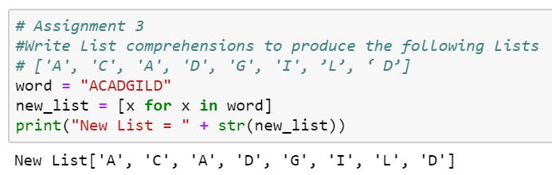

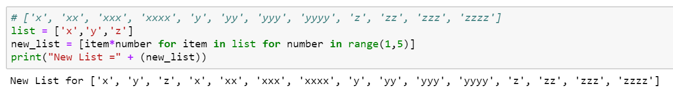

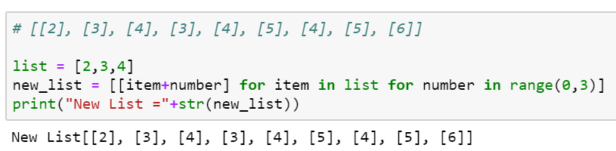

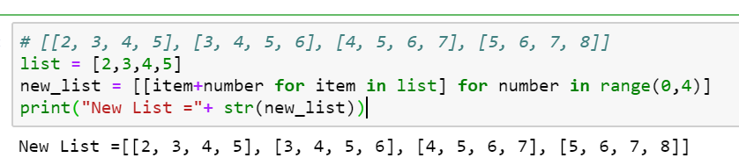

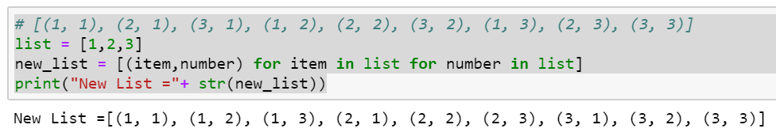

4. Implement a function longestWord() that takes a list of words and returns the longest one.

**Code**

# Implement a function longestWord() that takes a list of words and returns the longest one.

def find_longest_word(words_list):

word_len = []

for n in words_list:

word_len.append((len(n), n))

word_len.sort()

return word_len[-1][1]

print("The longest word is:")

print(find_longest_word(["This", "is","elephant","Sample"]))

**Screenshot**

